# COMSATS University Islamabad

## HUM102 Report Writing Skills Terminal Examinations

## Spring 2021

## Hybrid Course

**Time: 3 Hours Total Marks: 50**

### Student Name: Muhammad Ruslan Babar

### Registration Number: FA20-BSE-094

### Campus: Chak Shehzad Date: May 29 , 2021

### Moderator Name: Sir Anwar Mehmood

**Instructions to Students**

* Write your Name, Registration Number, Campus, Date and Moderator’s Name.
* Mobile phone, digital diaries or any other digital storage medium is not allowed.
* Type your answers on the same document provided as question paper.
* Submit the answer sheet via CU Online Console in the given time. No submissions are allowed via email.
* Attempt all questions.

**Declaration:** It is here by informed to all examinee that use of unfair means as defined by rules and regulations is considered as an academic offense of highest nature there is. All examinees found guilty shall be dealt with in accordance to the statutory rules pertaining to student conduct, discipline and examination. The University’s decision in all such matters shall be the final binding on all parties.

|  |  |  |  |  |  |  |
| --- | --- | --- | --- | --- | --- | --- |
| **For Faculty Use Only** | | | | | | |
| **Question** | **Q. 1** | **Q. 2** | **Q. 3** | **Q. 4** | **Q. 5** | **Total** |
|  |  |  |  |  |  |  |

#### Question 1 [5 + 5= 10 marks, CLO1-C1]

#### What factors should you consider while drafting the conclusion section of your report?

**Answer:**

Conclusions are logical deductions based on the data in the findings section. They are a complete synopsis of the discoveries and summarize the primary concerns of the report alongside featuring the critical components. They identify with the targets and end with an explanation which will prompt the suggestions.

* Summarizing your thoughts and convey the larger significance of your report study
* Exhibits the significance of your thoughts.
* Presenting conceivable new or extended perspectives about the exploration issue.
* Unity, coherence and support should be put into consideration.

**Example:**

**Conclusions:**

This report has identified five types of personal computers currently available. Some are primarily used for professional purposes such as the Mac-books; others are used more broadly in the workplace and home such as mini-computer and, some are personal pcs for student use. Specialized Super Computer are currently being incorporated into high businesses like space rockets controlling, weather forecasting.

#### What aspects should be covered while making recommendations in your report?

**Answers:**

The aspects that should be covered while making recommendations in report are:

* The author should ensure to give only those recommendations that can be implemented by researchers in a practical way.
* Absolutely innovative proposals are only a hopeless cause.
* In addition, they ought to be in light of the discoveries.

In term of writing the aspects to be kept in mind are:

**Brief:** compose compactly; justification should be given if necessary

**Clear:** don't be uncertain with regards to how the idea ought to be carried out.

**Exact:** unclear proposals typically result from lacking exploration/examination.

**For example:** what more should be possible in a similar region might be expressed from a specific perspective. Try not to give general proposals; it just shows you need to occupy space. Maybe, propose subjects for additional examination with the goal that others may profit with them.

#### Question 2 [10 marks, CLO2-C4]

Given below is an example of online technical document. Analyze it with respect to traits of technical writing and Seven C’s of effective communication. Identify the traits and explain how they are present in the given sample. For example, if you think its language is concise, give reason for your answer.

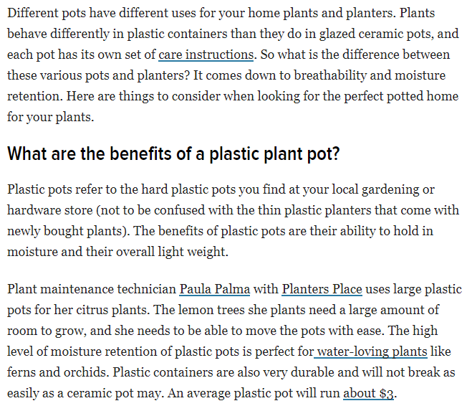

**Answer:**

This technical document has the following traits & characteristics:

**Traits**

• Accessible document design

The structure of the document letter to its audience is simple and is very easy to get through it.

* **Background**

(Discussion regarding plants and planters. Informing the readers about the breathability and moisture on plants and the container pots it require to be kept in.)

* **Heading is visible in an interrogative statement.**

(What are the benefits of plastic plant pots?)

* **Body**

(Body explains the different forms of pots and the technical methods of planting trees)

* **Ending**

The ending is not properly defined. It just gave the importance of plastic containers.

• Audience Recognition

This document idolizes the correct audience:

**General Public**

**Planter**

• Accuracy

The document is precise and contains the three main parts which are technical accuracy, Concise, style and documenting.

* Proper formatting.
* Concisely explained the benefits and precautions of plants and pots containers.
* Style is kept simple for better understanding.

**7 C’s Of Communication:**

If we look in to the document will find the following:

**Clear**: By looking into the document the information and the audience are clearly recognized.

* Planters, general public.

**Concise** The body of the document is concise as it only states

“What are the benefits of plastic plant pots?”

**Concrete** The reason behind the document is solid and to the point.

**Reason of writing:** Discussion regarding plants and planters. Informing the readers about the breathability and moisture on plants and the container pots it require to be kept in. And what are the technical ways to maintain a proper planting environment.

It does not have extra details which makes is easy to understand and concrete.

**Correct** The information and the point to be pondered is written in perfect form.

* Resignation from the position.
* Reason of resignation.

It has the main body that describes and clarify the point.

**Coherent** The document is in the proper flow, it is logical and goes down systematically. With introduction to the plantations and pots, reason of writing and resolution of the problem and ending.

**Complete** It has everything for the audience to understand and ponder over. From the problem to the solution everything is discussed and well written.

**Courteous** The document is very courteous with no harshness. In the end it tells the reader about the plastic containers (plants love plastic container).

#### Question 3 [10 marks, CLO3-A4]

#### Memorandum or Memo is generally used for quick short communication within an organization. However, its structure and function varies according to a given context. Differentiate between Trip Report Memo and Information Memo.

**Trip Report Memo VS Information Memo**

**Trip Report Memo:**

Trip reports are a basic part of communication at organization. Trip memo should include the reason for the trip, what was done at trip , and one or more conclusions.

**Construction:**

* To a supervisor after an employee returns from a business venture.
* First part has statement of purposes i.e. provides information on trip.
* Second part summarizes clearly and concise (**ideally**) outline of your trip.
* Third part involves a discussion (**highlight and emphasize important information**).
* Final part includes actions to be taken to rightly address the issue.

**Example:** Report for a Clinical trial. This report will provide all the necessary information to the organization regarding trip to clinic.

**Information Memo:**

An Information Memorandum (IM) is a document created by business owners for buyers. The primary objective of an Information Memorandum is to motivate potential investors to invest in your business. An Information Memorandum is the most effective way of providing a large volume of information related to a company to investors.

**Construction:**

* Information Memo is used to deliver or request information or assistance.
* First Paragraph provides main idea.
* Second paragraph expands on the details.
* Third paragraph outlines the action required.

**Example:**

Encyclopedia is also based on information report. It provides background information as well as the information necessary to understand the report problem. This includes analysis of the report and the conclusion based on the findings of report.

#### Question 4 [10 marks, CLO4-C3]

Suppose that you are a working employee in an organization and receiving several complaints regarding your colleagues reluctant to follow the SOPs. Consequently, several cases are being reported within the different departments at an alarming rate putting the lives of other individuals at stake. Compose a persuasion memo to your general manager starting from some statistics to present a rate at which the pandemic is rising. Then move to the negligence of employees to take the SOPs on a serious note and the resultant increase in the number of employees reported with COVID 19. Lastly conclude with some actions for your administration to undertake for safeguarding the workforce.

**Answer 4:**

**To:** Manager

**From: (**Senior Project Manager) **Ruslan Babar**

**Address:** Islamabad Pakistan

**Date:** May 29, 2021.

Subject: Requesting to control the alarming COVID situation inside company.

Dear Manager,

I hope you are doing well. The situation is really crucial in the country which have requires us to show sober mindedness. with over 23,000,000 active cases and approx. 75,000 daily new cases are really alarming.

Employers and employees are required to follow the SOPs in order to make the organization running. But several colleagues have showed negligence to take the SOPs on serious note and resultantly they are reported as covid-19 positive.

The reputation of company is badly affected. Therefore it is highly requested from the organization to take actions that administration can undertake for safeguarding the workforce:

* Working staff should be vaccinated.
* Persons above the age of 65 are required to stay at home.
* Only symptomatic staff and visitors should be allowed.
* Entrance must have a sanitizer dispenser.
* Virtual meetings should be held.
* Number of people in elevators shall be restricted duly maintaining social distancing.
* the organization should be desensitized on regular basis.

I'm sure that your good self will look into this matter in order to keep the organization running safe and sound with a lot more productivity in the Future, hopefully.

Sincerely,

*M.Ruslan Babar*

M.Ruslan Babar.

#### Question 5 [10 marks, CLO4-C3]

Suppose that vacancies have been announced under National Internship Program to gain one year experience working as an assistant in different ministries. Compose a cover letter to express your interest alongside highlighting your key points and qualification to present yourself as the best candidate for the job. Your cover letter should have a proper introduction, pertinent details and an expression of interest to offer your services.

**Muhammad Ruslan Babar**

**Soan Garden Islamabad**

**26th June, 2021**

**I.T Company**

**Islamabad Pakistan**

**Dear Sir,**

It is with great interest that I am applying for national internship program. When I read that vacancies have been announced under national internship program to gain one year experience, I felt that it was an ideal match with my career aspirations.

I have completed my graduation from Comsats University Islamabad with a significantly good GPA.

I have spent my past years focusing on my academic career and generating skills. I have brilliant in my academics and the past jobs and internships offered and I have excelled in every phase. Keeping in mind all these points, I think I would serve an asset as an assistant in different ministries.

I believe that I am an ideal candidate for the position due to my experience in Information technology. I have high command over:

* Programming
* Web development
* Graphic designing
* Mobile app development

In addition to this, I have a reputation of being a punctual and a hard worker who completes task well ahead before the deadline.

I would like you to consider me because I am highly interested and definitely a good choice. Feel free to contact me and setup an interview at your earliest convenience. You can reach me by my email ruslandurrani907@gmail.com or by way of phone 03105098769. I look forward to discussing with you my specialties.

Thanks for your time and consideration. Hoping you hear a reply from you.

**Sincerely,**

**M.Ruslan Durrani**

*Good Luck!*